Project Design Phase
Solution Architecture

Date | 26 February 2026
Team ID | LTVIP2026TMIDS65832
Project Name | Flight Finder
Maximum Marks | 4 Marks

Solution Architecture:
Flight Finder system is to develop a user-friendly, secure, and scalable platform that allows customers to search, filter, and book flights easily. This system serves as a bridge between airline inventory systems and customers by providing a seamless experience for browsing available flights, making reservations, and managing bookings.
- Enables users to search for flights by specifying source, destination, travel dates, and other preferences.
- Allows filtering and sorting of search results based on price, duration, stops, and airlines.
- Facilitates quick booking by collecting passenger details and processing payments securely.
- Administrators can manage flight inventory, schedules, and monitor overall system usage.
Example - Solution Architecture Diagram:

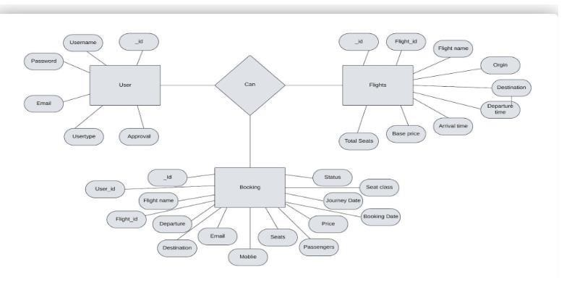
Figure 1: Architecture and data flow of the Flight Finder

